
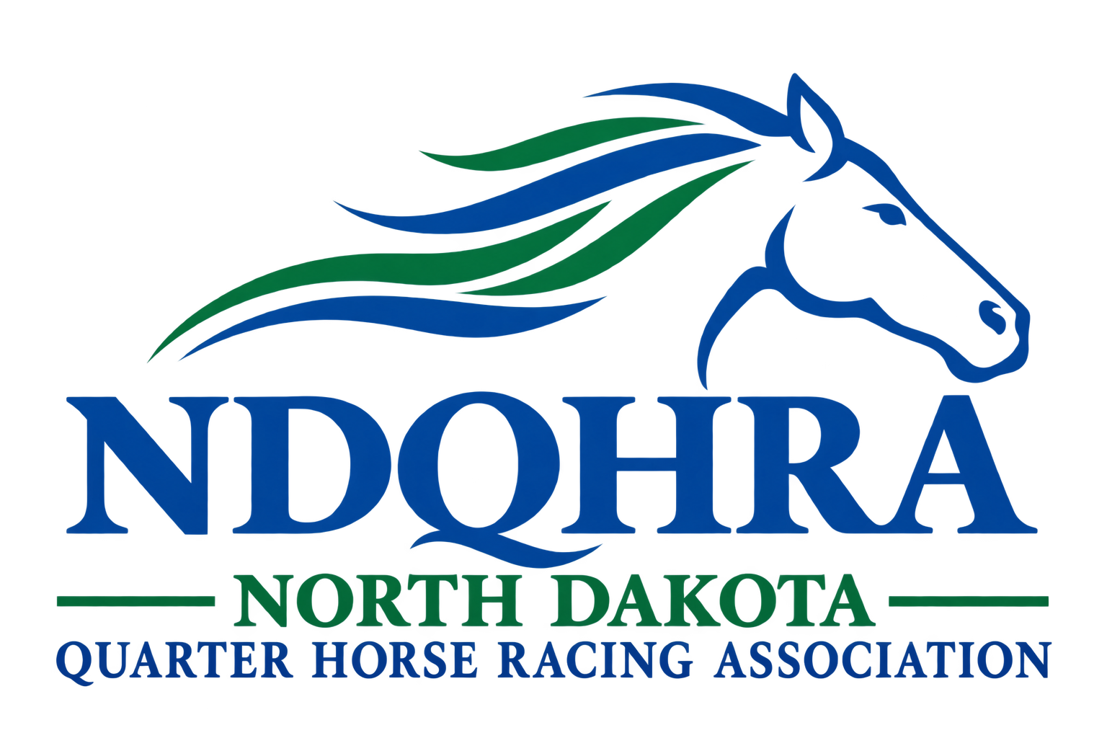
Cell Phone:

Thank you for your continued support of NDQHRA!

North Dakota Quarter Horse Racing Association
Leon A. Glasser, President
www.thendqhra.org

2027 NDQHRA Membership Form
Dues = $50.00
(Membership Expires: December 31, 2027)
Name(s) or Farm/Ranch:
*Please list the name you wish placed on your membership card and used in the newsletter.
Contact if a business is listed above:
Mailing Address:
City: State: Zip:
Home Phone:
Email:
Website:
Most communications are sent out using email including payment receipts. If you do not have an email address, please make sure we have the current mailing address.
As a Member you receive:
- Eligibility to enter special races.
- Awards.
- Invitation to the Annual Horsemen Awards Banquet.
- Voting Privileges at General Meetings
- Newsletters
- Payment Schedules
- AQHA Affiliated

To participate in the NDQHRA stakes races all owners must be NDQHRA members. Names must match all those required by AQHA for valid entries. For the North Dakota Certified Bred Races, if you are a current NDQHRA member, you are eligible to receive awards at the racetrack and at year-end.
Please mail your membership form and payment to: NDQHRA, PO Box 188, Mapleton, ND, 58059. Visit our website at: www.thendqhra.org

